Project Overview

I have some clients that need a way to import, edit, and export data. I’d like to offer them a User Web interface to Import csv, iif, xml, and xls files into a database, (real easy to decipher each). Edit records with rule matching and inline then export. This is long but detailed to keep the guesswork to a minimum which will save on time/cost. I have an admin dashboard purchased:  
https://pixinvent.com/apex-angular-4-bootstrap-admin-template/demo-1/datatables

Data will be imported into the following tables:

* User
  + Accounts
  + Imported
  + Exported (Moved here from Exported after verified complete)
  + Vendors
  + Rules

# Import Accounts & Cust Tables

We will import data from a IIF into Accounts & Cust_Vend_Emp Table.  
Pretty straightforward, we will add field data to database for: !ACCNT !VEND !CUST !EMP !OTHERNAME   
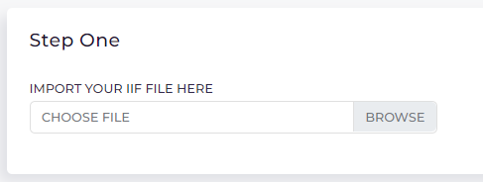

# Import Old Transactions

We will import data to “exported” table from a csv or xls.   
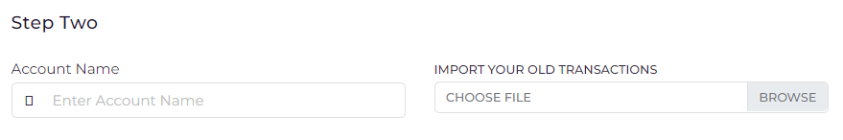

* During Import we will ask “Which account are you importing?”
  + Autocomplete input drop-down, matching = Accounts>NAME
  + If name typed does not match show warning:
    - “Are you sure you want to import transactions to a new account?”
    - If yes, Prompt for Account Type. Dropdown options accounttype>types
      * Ask what kind of account this is this AccountType>type
      * Then import
* Save account name and fields to DB
  + Save records to exported table
  + Save time/date exported>imported and Status: “5”
  + This uses header matching
    - Hard code these with, default matching as most will be the same
    - Type= TRNTYPE, *Date*= DTPOSTED, amount=TRNAMT, split=account, Num= CHECKNUM, Memo=MEMO balance=balance
* On import if “memo” is null we copy to name to memo
* We also copy name to name_og -and- memo to memo_og, so we have unalter backups

Old Transaction Rule Creation  
Use similar_text to find matches for many of the same in “Memo” Field .  
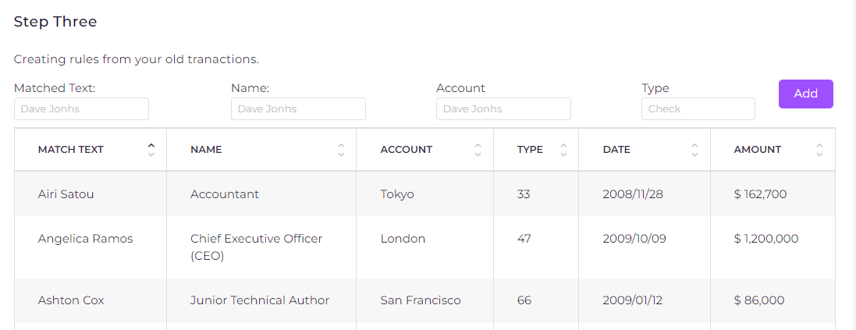

* After importing and Remove Common text from above, we show this step
  + This is taking place for an account/accountID selected during import.
* So here we look for “x” 3+ multiple entries that have the same “Name”, “Account” & “Type” then we try to find the common concurrent text “Match Text” Only display where ruleID=null
  + using similar_text % in NAME to display the top matching result first
  + Use the maximum concurrent matching text as input value
  + Value can be changed and will filter table results below
    - Again only showing results for “x” 3+
* We list matching the best first
* Name, Account, and Type is filled in from matched results
* Input box “3 Letter Badge” 3 Save a 3 character I badge
* Color selector

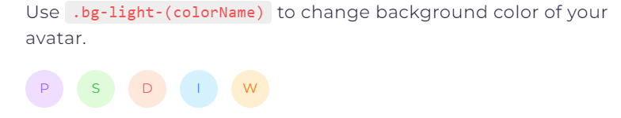

* + Select badge color
  + “Add” an entry to Rule table **(AKA RULE_ADD)**
    - Rule Table
      * Type= account
      * accountID = ID of current account
      * Added= date/time
      * Applied=date/time
      * Used=every time replace took place to a record +1
      * Matched_text = Matched Text input box
      * new_name = NAME
      * new_account = account
    - Exported (or Imported) Table
      * save ruleID
      * Change Name to rule>new_name
      * Change Account to rule>new_account
      * Edited = current date/time
      * Status = 3
* Save a 3 character I badge , if null:
  + Nate Beiley = NB, Paypal= PAY, Pay Pal = PP, Bank Of America= BOA
  + Bankofamerica= BAN, paypal 12/22=PAY, pay pal 12/22 = PP
    - * Badge color 

# Remove Common text from Name

* This happens after import of ~~Old Transactions and~~ Imported transactions
  + This is taking place for an account/accountID selected during import.
* Before we display the table we actually run this for any already created rules
  + Look for in rules where type=remove, accountID=matched
    - Replace Matched_text with new_name
  + Have a button “Undo All” at top of table
    - This will copy name_or to name
    - And delete records from rules where accountID=current and Type=remove
    - And reload/display table data
* A “Match Text” input box at top of table, it shows/filters results below as you type for name field
* This will remove common (entered) text from “Name” field
  + I would like to use some expressions, and one custom one for novice users
    - ?, +, * , ^ $,
    - # = [0-9, \#] so # can be any number or #
* We have a “Replace With” input box that is null, placeholder=”Leave blank to delete”
* “Replace” button will replace all matched name fields
  + Create a record in rules
    - Type= remove
    - accountID = ID of current account
    - Added= date/time
    - Applied=date/time
    - Used=every time replace took place +1
    - Matched_text = Matched Text input box
    - new_name = Replace With input box

Import to: Imported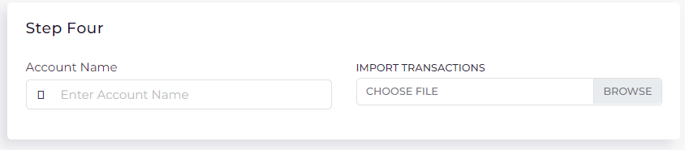

* Ask “Which Account are we importing?”
  + Dropdown Autofill from accounts>NAME as you type account name
* We import a CSV, XLSx, or QBO file to Imported table
* For CSV/XLS we need to do header matching for Name, Memo, Type, Date/Time, Amount, ID
* This ends up being a near exact copy of “Import Old Transactions” except we import to imported
* Set status to 1
* After import run Match Rules where Account= current Account
  + Update NAME and Account
  + Set edited to current date/time
  + Set ruleID to ruleID of match
  + Set status to 2

Make Rules

* **This is Just like Old Transaction Rule Creating, but with less functions, so I will repeat**
  + Where we show account table data for select account/id
    - via dropdown, options are only whatever account IDs are in imported table.
      * Select first accountID in table by default
      * Can we have an “List All Imported Transaction” option
        + List any in Imported with any accountID
* So above table header we have,
  + Above Account dropdown
  + Matched Text input box
    - As you type text, we filter NAME for matched accountID
    - I want to show records for both imported and exported records as you type,
      * imported first
  + Name, Text input box, autofill dropdown from vendor>NAME
  + Account, Text input box, autofill dropdown from vendor>Account
  + Amount, Text input that is null, not prefilled with data
    - If amount is typed we also filter table data by this
    - If not null display warning “Note, the rule recreated will also need to match the amount enter, Continue or Cancel?”
  + Badge, text input box, 3 letter input
  + Badge_c, dropdown of sort to select badge color
  + ADD button to add rule
    - See **(AKA RULE_ADD)**
* Table lists record data, sortable from header

Edit/Delete Rule

* A simple way to view rules table by account and edit or delete them
  + Very similar to Make Rule except we are showing data for rule table
  + With an edit button and a delete button
  + When rule is edited or deleted we:
    - Find matching ruleID in imported and:
      * Copy memo_og to memo
      * Copy name_og to name
      * Delete imported> account, ruleID, edited, field
      * Set imported>status=2
      * Rerun “Remove Common text”
  + If editing we open **“Make Rule”** table for selected account/ID
    - We fill in input boxes with data from fields
    - Write to same ruleID
  + If deleted we:
    - Delete ruleID

# In line edit Imported

* 25/50/100 per page
* Show each line of Imported_trans
* Account/ID Dropdown default to show all
* Hide Match check box
  + Hide match checked = display where ruleID is null and status=2
  + Bulk options (Match, Unmatch, Delete)
    - Match = status 3
    - Unmatch = status 2
    - Delete removes record
* Tab through to change
  + Inline tabbing through, Name, Account, Memo, Match (checkbox)
    - If we tab past match check-box, can we check it as we tab past it
      * check box to true for “match” status=3, else 2
  + Update imported>edited
  + Typing in is auto-filled with matching vendors>NAME and Accounts>NAME

# Export

* Export all records in imported
  + This is a CSV/IIF format see example
  + If user>max_export is not null, we only export x number
    - Will have an option to subscribe.
  + If user>max_export or user>exp_date past, display popup sorry…
    - Will have an option to subscribe.
* Save imported>exported date/time to all records
* Change status to 4 for all exported
* After export we need to show a popup on pages when logged in
  + This popup is displayed on page loads when any Imported>status=4
  + Did you complete your import from Month Day Year at Time?
    - Select YES, we change status to 5 and move to Exported
    - If NO
      * Would you like to redownload?
        + Redownload CSV/IIF
      * Or delete and start over
        + Delete all records in imported table

## User Authentication

* Users Login/create, with email, google, apple,FB
  + Email, First Name, Last Name, Company, Cell Phone, work phone
  + User verify email
  + Set user>max_export to 20
  + A subscription option with set user>exp_date
* Basic Admin control of users

# Table Structure

Note, uppercase was used to show fields that will match imports from .IIF & .qbo

## Account Table Name: accounts

* accountID = unique ID
* Imported = Date/Time of last import that used this account name/id
* added = Date/Time record was added
* acctid = .qbo will have this field, some csv's will have an account number in header
* NAME REFNUM TIMESTAMP ACCNTTYPE OBAMOUNT DESC ACCNUM SCD BANKNUM EXTRA HIDDEN DELCOUNT USEID

## Cust_Vend_Emp Table Name: vendors

* vendorID = unique ID
* type = this is in IIF: VEND, CUST, EMP, OTHERNAME
* added = date/time account record was created
* ADDR1 ADDR2 ADDR3 ADDR4 ADDR5
* All BADDR# fields will be saved to ADDR# fields
* NAME REFNUM TIMESTAMP INIT CITY STATE ZIP SSNO PHONE1 PHONE2 FAXNUM EMAIL NOTE NOTEPAD SALUTATION COMPANYNAME FIRSTNAME MIDINIT LASTNAME SALUTATION CUSTFLD1 CUSTFLD2 CUSTFLD3 CUSTFLD4 CUSTFLD5 CUSTFLD6 CUSTFLD7 CUSTFLD8 CUSTFLD9 CUSTFLD10 CUSTFLD11 CUSTFLD12 CUSTFLD13 CUSTFLD14 CUSTFLD15 JOBDESC JOBTYPE JOBSTATUS JOBSTART JOBPROJEND JOBEND DELCOUNT PRICELEVEL 1099
* HIDDEN = If hidden "Y" do not show in results

## Imported_Trans and Exported_Transaction Tables Name: imported & exported

QBO files are close to XML files, but sometimes missing the closing tags and sometimes the header is just open. No header matching for .qbo needed, they should match the uppercase below. Stared* = required header match for import.

* accountID = unique ID
* imported = Date/Time of import
* exported = Date/Time of export
* edited = Date/Time of edited
* ruleID = rule id of matching rule applied
* verified = Date/Time of verified complete export
* ACCNTTYPE
* TRNTYPE = Use for headed csv xls import match, label “Transaction Type”
* DTPOSTED = “” csv xls import match, label “Transaction Date Posted”*
* TRNAMT = “” csv xls import match, label “Transaction Amount” *
* FITID
* NAME = “” csv xls import match, label “Transaction Name or Description” *
* MEMO = “” csv xls import match, label “Transaction Memo or Description”
  + If null copy from NAME on import
* CHECKNUM = “” csv xls import match, label “Transaction Check/Doc Number”
* Account = null from import, will be used during rule matching or inline editing
* m_cat = “” csv xls import match, label “Transaction Merch Category”
* e_cat = “” csv xls import match, label “Transaction Expense Category”
* Account
* balance
* name_og = Copy of NAME on import
* memo_og = Copy of MEMO on import
  + If memo was null copy from NAME
* badge = this is a 3 character max badge
* badge_c = badge color

## Rule Matching Table Name: rules

* ruleID = Unique ID
* accountID = D of accountID
* Type = 3 types:
  + - * Account (account name match)
      * Remove (remove text from name match)
      * Field (field name header match from import)
* Added = Date/Time of rule added/created
* Applied = Date/Time of last applied
* Used = How many x used
* match_text = this is the text used that search imported>NAME for match
* match_amount = this is the amount used that search imported>TRNAMT for match
  + - * this is rarely used
* new_name = this is the new NAME that will be applied and saved to imported>NAME
* new_account = this is the Account name that will be applied and saved to imported>Account
* field_name = this is the header field of import that was matched to NAME during csv import
* field_memo = this is the header field of import that was matched to NAME during csv import
* field_dtposted = this is the header field of import that was matched to dtposted during csv import
* field_trnamt = this is the header field of import that was matched to trnamt during csv import
* field_transtype = this is the header field of import that was matched to transtype during csv import
* field_m_cat = this is the header field of import that was matched to m_cat during csv import
* field_e_cat = this is the header field of import that was matched to e_cat during csv import
* badge = 3 letter badge
* badge_c = badge color

## AccountType

* Type
  + Add these records:

Bank, Loan, CreditCard, Equity, Checking, Saving

* export_name
* These are currently exactly the same
  + Bank, Loan, Credit Card, Equity, Checking, Saving

1 Setting up table data import for: Accounts, Vendors, OldTransactio, Imported Transaction - Completed

2 Old Rule Creation, Import to: Imported, Make Rules

3 Inline edit Imported, Edit/Delete Rules

4 Export Data, User authentication, bug fixes

5 product delivery complete